USING A TRANSFER BELT
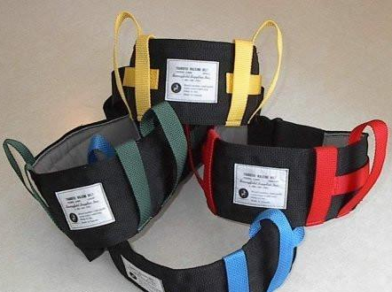
Transfer belts are pieces of equipment that may be recommended by a physiotherapist for clients who require hands-on assistance for balance, to assist them to move around safely.

The belt has multiple straps around it running vertically, and these may be effective handholds. It is safer to assist a client while holding onto the handles of the transfer belt rather than grasping them under the arm or by a piece of their clothing.

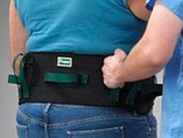
The belt is not, under any circumstances, to be used as a lifting device.
A client should never be lifted by the handles on the belt.

Only use a transfer belt when it has been recommended by a therapist. A transfer belt must not be used with another client without therapist assessment and recommendation.

BEFORE USING A TRANSFER BELT

- Do not use a transfer belt if the client has open wounds or rashes in the area.
- Make sure the belt fits the client’s waist properly. Changes in clothing can affect the way the belt fits.
- Keep the belt clean by washing it with cold soapy water. Dry before use.

HOW TO USE A TRANSFER BELT

- Fasten the belt around the client’s waist. The belt should be secured snugly around the client’s waist over top of their clothing. The handles on the belt face out so that the caregiver supporting the client can get a handhold.
- Adjust the straps for a good fit. The best fit accommodates two fingerbreadths from the client’s waist.
- Use the belt as instructed by the Physiotherapist. A transfer belt may always be necessary or only when using specific equipment.
USE OF A TRANSFER BELT FOR TRANSFERS

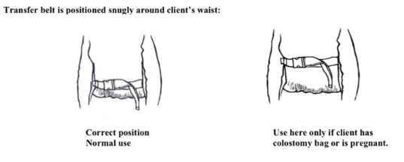

USE OF A TRANSFER BELT FOR ASSISTED WALKING

