
COMMUNITY THERAPY SERVICES INC.
101 – 1601 Buffalo Place 101 – 1601 Buffalo Place

Winnipeg, MB R3T 3K7

Téléphone (204) 949-0533 Telephone Télécopieur (204) 942-1428 FAX

PROM (PASSIVE RANGE OF MOTION)
FOR THE ARMS
LYING PROGRAM

Client Name: _____________________
Date: _____________________
Therapist: _____________________
Frequency: _____________________

*Note: - For all exercises, caregiver stands at the side of the bed.
- Where possible, raise bed to waist height of caregiver
- ________________________________________________

FINGERS/THUMB

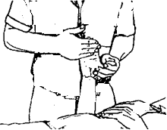
- Support hand and wrist with one hand
- Keep wrist straight at all times
- Gently bend fingers
- Straighten fingers out
- Repeat with the thumb (as in diagram)
Hold _____ seconds
Repeat _____ times
Right _____ Left_____

 PROM FOR THE ARMS – LYING page 2
Client: __________________

WRIST BACK AND FORWARD

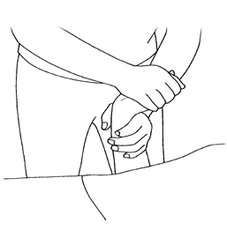
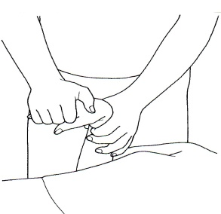
- Bend elbow and support forearm
- Hold palm of hand, not the fingers
- Bend wrist forward
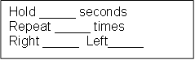
- Bend wrist back

WRIST SIDE TO SIDE
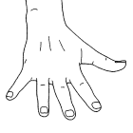
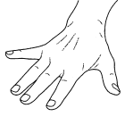
- Support forearm above wrist
- Hold palm of hand
- Move hand to one side slowly
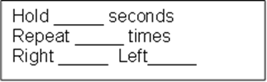
- Move hand to the other side slowly

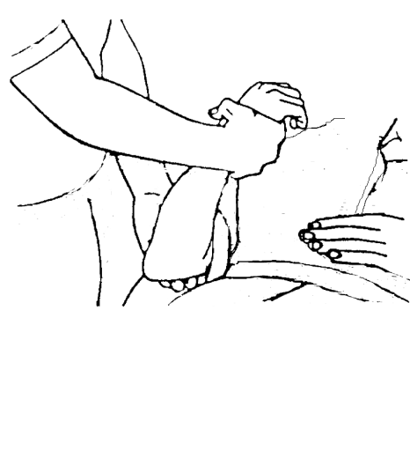
ELBOW BEND AND STRAIGHTEN

- Support upper arm with one hand
- Grasp wrist
- Bend elbow turning palm up
- Straighten elbow turning palm down
Hold Bent _____ seconds
Hold Straight _____ seconds
Repeat ____ times
Right _____ Left_____
 PROM FOR THE ARMS - LYING page 3
Client: __________________

SHOULDER FORWARD
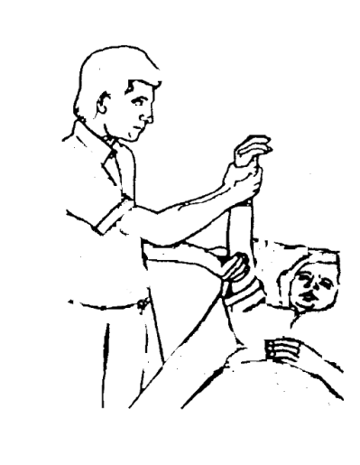
- Support wrist and elbow
- Raise arm up as far as comfortable
Hold ____ seconds
Repeat _____ times
Right _____ Left _____

SHOULDER TO THE SIDE
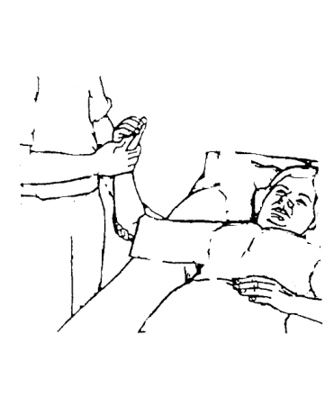
- Support wrist and elbow
- Slide arm out to side to shoulder level
Hold _____seconds
Repeat _____ times
Right _____ Left _____

SHOULDER TURN OUT
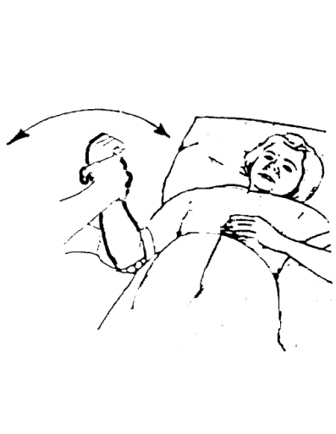
- Support wrist and elbow
- Keep elbow bent at 90 degrees
- Keep elbow against body at all times
- Move hand away from stomach
Hold _____ seconds
Repeat _____ times
Right _____ Left _____

