Equipment Prescription

Name:_________________________________________ Diagnosis: ___________________________________
The Occupational/Physical Therapist is recommending the following equipment. If you have an insurance plan, submit this form with accompanying receipt(s) for reimbursement.

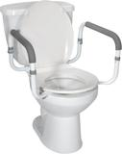  Toilet Safety Rails | 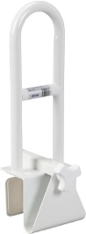  Clamp-on Tub Bar | 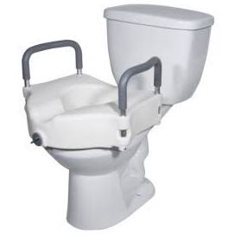  Raised Toilet Seat with Armrests | 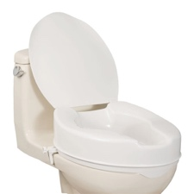  Raised Toilet Seat  Height: ____” | 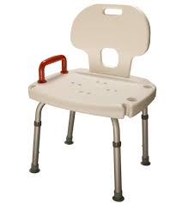  Bath Seat | 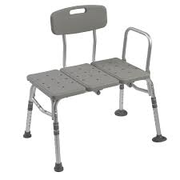  Tub Transfer Bench
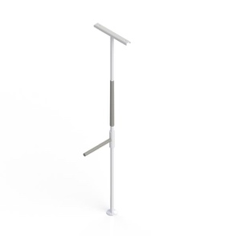 Floor-to-Ceiling Pole | 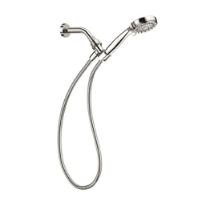 Handheld Showerhead | 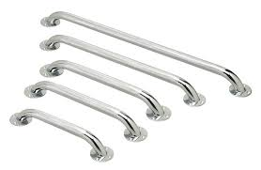 Grab Bars  Length: ____” | 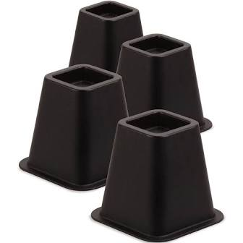  Furniture Risers | 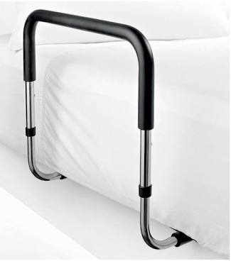  Bed Rail | 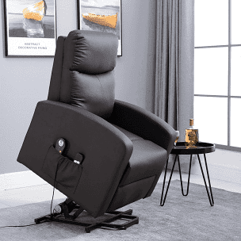  Electric Lift Chair
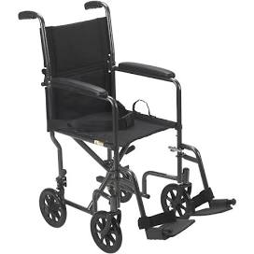  Transport Chair | 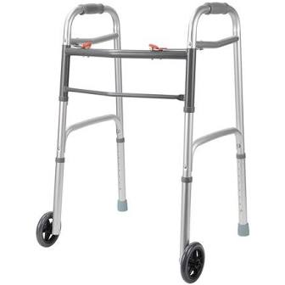  2-wheeled walker | 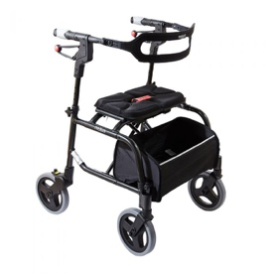  4-wheeled walker  Handle Height: ___”  Seat Height: ____” | 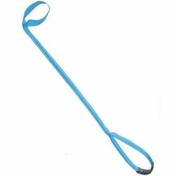  Leg Lifter | 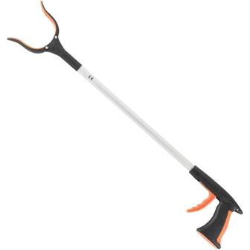  Long-Handled Reacher | 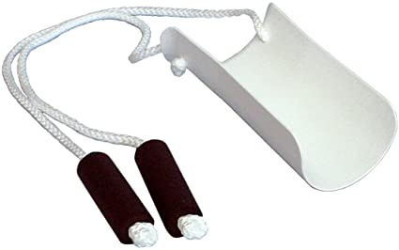  Sock Aid
Recommended Equipment:
__________________________________________________________________________________________________________________________________________________________________________________________________________________________________________________________________________________________
Prescribed by: ____________(Occupational/Physical Therapist) Signature: _________________________________
Contact #: (204) 949-0533 Ext. ______ Date: ___________________
OT/PT Registration # : __________ Physician’s Signature (if required): ___________________

Assistive Healthcare Products http://www.assistivehealthcarewinnipeg.ca
Address: 115-1100 Concordia Ave.
(inside Medicine Shoppe Pharmacy)
Phone: 204-487-2257; Fax: 204-661-1949
Email: Assistivehealthcare@gmail.com
Hours: Mon–Fri 9–6:00; Sat 10–3:00
Delivery: Free within Winnipeg
Equipment: New/rental adult mobility aids /wheelchairs (no tilt); ADL/home safety equipment

Concordia Community Pharmacy
https://www.concordiaclinic.ca
Address: 1095 Concordia Ave.
(inside Concordia Hospital)
Phone: 204-669-4500; Fax: 204-669-0532
Email: a_bhardwaj2000@yahoo.co.in
Hours: Mon–Fri 9:00–5:00
Equipment: New mobility aids; ADL/home safety equipment

Diamond Athletic Medical Supplies https://www.diamondathletic.com
Address: 75 Poseidon Bay
Phone: 204-488-7820; Fax: 204-488-0294
Email: info@diamondathletic.com
Hours: Mon–Fri 8:30–6:00 Sat 10–4:00
Delivery: Free within Winnipeg
Equipment: New mobility aids; ADL/home safety equipment

Eco Medical Equipment
https://www.ecomedical.ca
Address: 190-117 King Edward St. E.
Phone: 204-788-0009; Fax: 204-788-0022
Email: natalies@ecomedical.ca
Hours: Mon–Fri 8:30–5:00
Delivery: Free over $75 within Winnipeg
Equipment: New/rental adult mobility aids/ wheelchairs (no tilt); ADL/home safety equipment

HomEquip
http://www.homequip.ca
Address: 385-550 Century St.
Phone: 204-949-2300; Fax: 204-774-2191
Email: homequip@homequip.ca
Hours: Mon–Fri 8:30–5:00
Delivery: Fees vary within Winnipeg
Equipment: New/used/rental adult/child mobility aids/wheelchairs (tilt available); ADL/home safety equipment

HT Mobility Medical
https://htmobilitymedical.ca
Address: 451A Henderson Hwy.
Phone: 204-668-6111; Fax: 204-663-4657
Email: service@htmobilitymedical.ca
Hours: Mon–Fri 8:30–4:00; Sat 10–3:00
Delivery: Free within Winnipeg
Equipment: New/rental adult mobility aids/ wheelchairs (tilt available); ADL/home safety equipment

Innovative Medical Supplies https://www.innovativemedicalsupplies.org

2 locations:
Address: 217 Henderson Hwy
Phone: 204-663-6633; Fax: 204-663-2452
Email: info@innovativemedicalsupplies.com
Hours: Mon–Fri 9–5:30; Sat 10–3:00

Address: 8-2727 Portage Ave.
Phone: 204-896-1990; Fax:204-896-1996
Email:courts@innovativemedicalsupplies.com
Hours: Mon-Thurs: 9-5:30; Fri 9–5:00

Delivery: Fees vary within Winnipeg
Equipment: New/rental adult mobility aids/ wheelchairs (no tilt); ADL/home safety equip

Liberty Athletic & Medical Supplies https://libertymed.ca
Address: 264 Taché Ave.
Phone: 204-272-9640; Fax: 204-272-9641
Email: info@libertymed.ca
Hours: Mon–Fri 10–6:00, Sat 10–2:00
Delivery: Fees vary within Winnipeg
Equipment: New/rental mobility aids/ wheelchairs (no tilt); ADL/home safety equipment

Motion Winnipeg
(formerly Canadian Health Care Products)
https://www.motioncares.ca
Address: 6-3166 Portage Ave.
Phone: 204-832-9963; Fax: 204-888-9609
Email: winnipeg@motioncares.ca
Hours: Mon–Fri 8:30–5:00
Delivery: Fees vary within Winnipeg
Equipment: New/used/rental adult/child mobility aids/wheelchairs (tilt available); ADL/home safety equipment

Moxley’s Rentals
http://moxleysrentals.ca
Address: 181 Osborne St.
Phone: 204-452-3434; Fax: 204-287-8134
Email: (sales) davidmoxley@shaw.ca
(equip. service) moxleysrental@gmail.com
Hours: Mon–Fri 7–6; Sat 7–4; Sun- please call
Delivery: Fees vary within Winnipeg
Equipment: Rental adult/child wheelchairs and mobility aids (no tilt)

Northland Healthcare Products Ltd. https://www.nhcp.com
Address: 865 Bradford St.
Phone: 204-786-6786; Fax:204-783-7496
Email: order@nhcp.com
Hours: Mon–Fri 8:00–4:00
Delivery: Fees vary within Winnipeg
Equipment: New adult/child mobility aids/ wheelchairs (tilt available); ADL/home safety equipment

Orthopedic and Medical Supply Source http://www.orthopedicandmedicalsupplysource.com
Address: 790 Sherbrook St (inside Mb Clinic)
Phone: 204-772-8322; Fax: 204-772-8331
Email: sales.omss@mymts.net
Hours: Mon–Fri 8:00–4:00
Delivery: Fees vary within Winnipeg
Equipment: New/rental mobility aids; ADL/ home safety equipment

Quality Life Services
http://qualitylifecares.com
Address: 980 Nairn Ave.
Phone: 204-663-3562; Fax: 204-663-1439
Toll Free: 1-800-363-0769
Email: info@qualitylifecares.com
Hours: Mon–Fri 8:30–4:30
Delivery: Free over $35 within Winnipeg
Equipment: New/rental adult mobility aids/ wheelchairs (no tilt); ADL/home safety equipment

Re-New Mobility
https://www.renewmobility.ca
Address: 1- 940 Lorimer Blvd.
Phone: 204-453-6473; Fax: 204-453-7086
Email: info@renewmobility.ca
Hours: Mon–Fri 9:00–5:00
Delivery: Free over $75 within Winnipeg
Equipment: New/used/rental adult mobility aids/wheelchairs (tilt available); ADL/home safety equipment

Reliable Mobility and Custom Seating https://www.reliablemobility.com
Address: 1046 Portage Ave.
Phone: 204-774-6322; Fax: 204-772-2754
Email: info@reliablemobility.com
Hours: Mon–Fri 9:00–5:00
Delivery: Fees vary within Winnipeg
Equipment: New/used/rental adult/child mobility aids/wheelchairs (tilt available); ADL/home safety equipment

SpiritRx Services
(formerly Grand Medicine)
https://www.gmhs.ca
Address: 15-801 Century St.
Phone: 204-885-0768; Fax: 1-877-612-2133
Email: contact@gmhs.ca
Hours: Mon–Fri 9:00–5:00
Delivery: Free within Winnipeg
Equipment: New Adult/child mobility aids/ wheelchairs (no tilt); ADL/home safety equipment

Stevens Home Medical Supply https://stevenshomemedical.com
Address: 700 William Ave (inside HSC)
Phone: 204-787-3532; Fax: 204-787-3552
Email: w-store@stevens.ca
Hours: Mon–Fri 8:00–5:00
Delivery $15 if under $150 in city
Equipment: New/rental adult/child mobility aids/wheelchairs (no tilt); ADL/home safety equipment

Tache Pharmacy at Seven Oaks Hospital http://www.tachepharmacysevenoaks.com
Address: 2300 McPhillips St.
Phone: 204-633-2233; Fax: 204-633-2244
Email: info@tachepharmacysevenoaks.com
Hours: Mon–Fri 9:00–5:00
Delivery: $5.00+ within Winnipeg
Equipment: New adult mobility aids/ wheelchairs (tilt available); ADL/home safety equipment; rental walkers available

The Access Store
https://theaccessstore.com/
Address: 324B Keewatin St.
Phone: 204-589-8955; Fax: 204-586-7040
Email: info@theaccessstore.com
Hours: Mon–Fri 9–5:00
Delivery: $15.00 within Winnipeg
Equipment: New adult/child mobility aids/ wheelchairs (tilt available); ADL/home safety equipment



